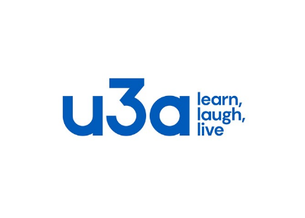
University of the Third Age, Caerphilly
U3A Caerphilly is for people who have retired from full time work or caring responsibilities and who would like to join others in the local area to pursue educational, creative and leisure activities.
If you would like to join us, please complete this form and send it with the current annual membership fee of £15 or £10, as detailed below to:
The Treasurer, U3A Caerphilly, 5 Heol-Y-Wern, Caerphilly, CF83 3EY
-----------------------------------------------------------------------------------------------------------------
I would like to join U3A Caerphilly and enclose (please tick the correct option):

Full membership fee of £15
Discounted membership fee of £10
Because I am also a member of U3A ___________________

Please make cheques payable to U3A Caerphilly

Name ________________________________________________________

Address ________________________________________________________

Post Code ________________________________________________________

Telephone ________________________________________________________

Email ________________________________________________________

Signature ________________________________________________________

Please note:
- U3A Caerphilly holds your personal details in strictest confidence
- Your email or postal address will be used solely to notify you of our activities
- Your postal address will be passed to the Third Age Trust so that they can send you the monthly ‘Third Age Matters’ magazine (this is free to you as part of your membership).
-----------------------------------------------------------------------------------------------------------------
How did you find out about Caerphilly u3a? _________________________________

Office Fee
Use only Paid ____________ Signature ___________________ Date___________

